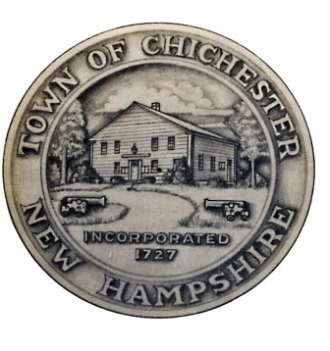
Town of Chichester

Trustees of the Trust Funds
54 Main Street

Chichester, New Hampshire 03258
(603) 798-5350 Fax (603) 798-3170

Trustees
Robert Lewis
Blaze Konefal
Richard Pratt

Da
June 24,2019

Attendees: Blaze Konefal, Richard Pratt, Robert Lewis

April 16,2021

Approved March 19, 2021 minutes

Determined what bank balance consists of.
Sent in cemetery trust details to ThreeBearings
Next meeting: May 21, 2021

Respectfully submitted,
Blaze Konefal
Richard Pratt
Rober Lewis

